Curriculum Vitae
personal Information
Name | Saad Nazeh Saad Abd El Fatah | 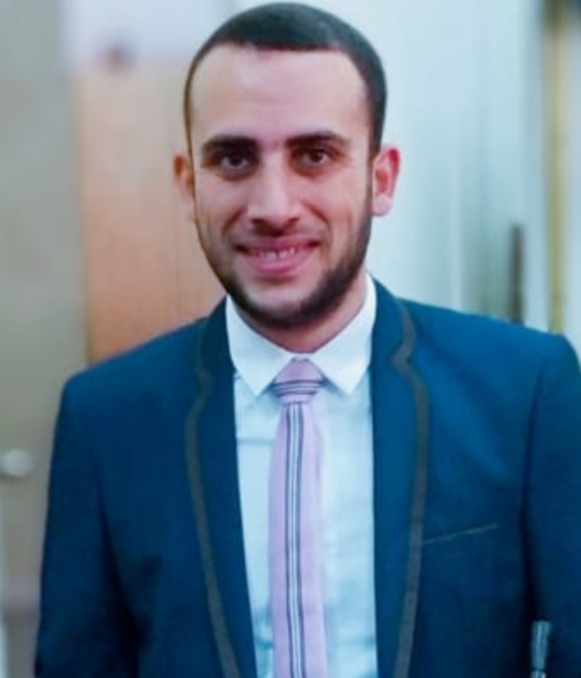
Title | Teaching assistant
Date of birth | 5-1-1994
Place of birth | Behera governorate
Citizenship | Egyptian
Contact Information
Home phone
Work phone
Mobile phone | 01018929065
E-mail (s) | Saad.vet355@cu.edu.eg
Web site (s)
Current Address | Faisal - Giza
Educational Qualifications
Academic Positions/ Demonstrator (2018)- M.V.Sc. (2021)

Thesis Title/ Influence of thermal manipulations on quail embryo during embryogenesis and post hatching
Areas of experience/
- Applied Anatomy
- Developmental embryology and Molecular Embryology
-Stem cell therapy
Projects
Awards
Professional Qualifications
Conferences
1-The seventh international scientific conference of Arab society, stem cells and molecular biology.

2-Stem cells workshop at faculty of veterinary medicine, Cairo university

Training courses
• Research Ethics at the faculty and leadership Development Center, Cairo University (FLDC).
• Communication skills, FLDC certificate.
• E- Learning, use of technology in teaching, FLDC certificate.
• Examination techniques and student evaluation, FLDC certificate.
• The credit hours system, FLDC certificate.
• I had training in many veterinary clinics then I had my own veterinary clinic.

Computer Skills
Professional in word, power pint, excel

Language Skills
• Excellent in Arabic (the mother language) and English.

Professional Memberships
Other activities /
• I had training in many veterinary clinics then I had my own veterinary clinic
List of publications

1-El-Shater, S. N., Rizk, H., Abdelrahman, H. A., Awad, M. A., Khalifa, E. F., &Khalil, K. M.(2021). Embryonic thermal manipulation of Japanese quail: effects on embryonic development, hatchability, and post-hatch performance. Tropical Animal Health and Production, 53(2), 1-10.

2-El-Shater, S. N., Rizk, H., Khalifa, E.F., & Khalil, K. M. (2020).Thermal Manipulation on Japanese quail embryo; An Embryological Study Veterinary Medical Journal-Giza.

Publications statistic
Journal’s Publication |  | Conference’s Publication |  | Authors |  |  | Total
Local | International | Local | International | Single | Shared |  | Total
 |  |  |  |  | Internal | External | Total
One research | One research

